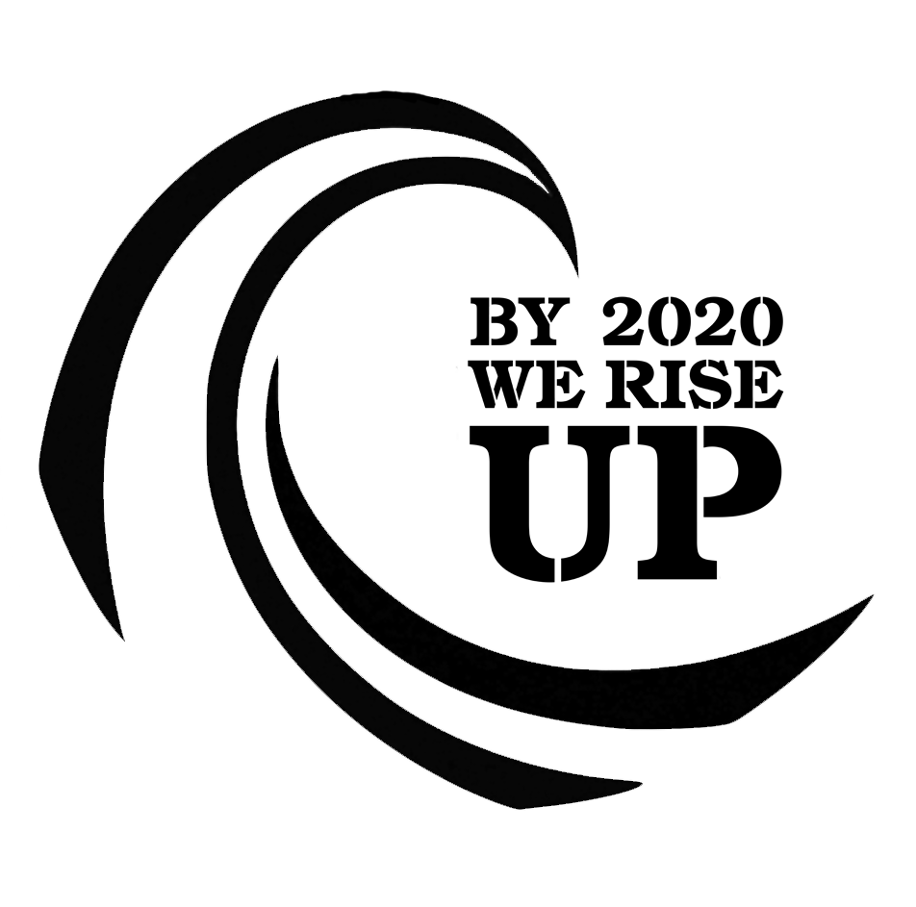
By2020WeRiseUp: Communication package #1

Partisan snippets (e.g. social media)

We're part of groups and people rising up across countries and movements all over Europe. Take action, join us!

The climate crisis has already begun, it is already a horrible reality and it's going to get worse if we don't act right now. We may choose to take different kinds of action - but we all need to take action ourselves and act now. To limit climate change to 1.5°C we cannot afford to wait and lose just one more year. We are rising up right now.

This is why we need to change the very system that is causing the climate crisis. Our most powerful weapon in this struggle is the realization that we have the power to do it. We are the ones who make the system work – not the political and economic decision makers. If we all decide to take action, we can stop the climate crisis! We can build a better future!

By 2020 We Rise Up: We are not alone in this! From Sweden to Greece, from Portugal to Poland, from all over Europe, we are rising up together with groups from various struggles. We call on everyone who accepts and embraces the fact that it is our diversity that makes us truly powerful. We call on everyone who feels like no one cares, to stand up and join the rest of us.

Neutral information text (e.g. press release)

We highly recommend describing your own action and presenting your demands first! Then, if you want, add and adapt what you find helpful from the following, and leave the rest.
Possible addition to the title of your press release: By2020WeRiseUp – Wave of climate action(s) all over Europe

By2020WeRiseUp: Across countries and movements, people and groups are rising up this autumn, and as many as never before. From the 20th to the 27th of September, millions of people are going to raise their voices for climate justice. However, action is not only taken by the youth, it does not only concern the climate crisis and it will not only take place in September. Groups from all over Europe are rising up during a first wave of coordinated actions from September to October.

Groups from different regions, and struggles are unified by a clear message. As [spokesperson XY] states: "The climate crisis has already begun and it's going to get worse if we don't act now. To limit global heating to 1.5°C we cannot afford to wait and lose just one more year. We are rising up right now." The climate crisis and other crises are already a horrible reality and time is running out. The groups that have gathered behind the rallying cry of By2020WeRiseUp are taking different kinds of actions. They are adamant that action needs to be taken right now.

While the threat has been known at least since the 1970s and the global community agreed at the 1992 UN Earth Summit that climate change posed a global and existential threat, decades of inaction and wholly insufficient measures have made the climate crisis – and many other crises – a brutal reality at the present day. This situation persists even though scientists and activists around the world have raised awareness and have loudly protested by organizing marches, petitions, mass actions, and many other types of action for years. At this point it is abundantly clear that the powerholders of the current system will not take the necessary steps to keep the planet habitable. Business as usual means inaction, which will lead to horrific consequences. The groups coordinating their actions under the umbrella of By2020WeRiseUp are convinced that fundamental change is needed to overcome the current crises.

By2020WeRiseUp is a rallying cry for groups and people to come together for transformative action in numbers never seen before in Europe. It makes people believe again in the possibility of radical change, and provides a facilitation platform and tools to connect political struggles related to climate justice, social justice, and other issues. By2020WeRiseUp is a coordination effort and does not itself organise actions, issue press releases, or speak in the name of participating initiatives.

Further information

For an overview of everything that's happening during the first wave, see our live-feed: https://by2020weriseup.net/live-feed/

For further offerings and guidelines on external communication, please see: https://by2020weriseup.net/how-to-external-communication/

If you want your actions to be given publicity and associated with By2020WeRiseUp, use the Hashtags: #By2020WeRiseUp or for short #By2020

For the By2020WeRiseUp twitter account: https://twitter.com/By2020WeRiseUp

For the By2020WeRiseUp mastodon account: https://todon.nl/@By2020WeRiseUp

For announced actions in the context of By2020WeRiseUp: https://by2020weriseup.net/actions/

One exemplary action we'd like to highlight this time around is a weekend of coordinated action in Münster, Germany. It's titled 'Klimaalarm' or climate alarm and you can find further information about it on the By2020-website or their own website.

